Exercise 1

## Hardware

- Processor: AMD Ryzen 7 4800H with Radeon Graphics (2.90 GHz)

- RAM: 8,00 GB (7,42 GB usable)

- Disk: 1TB SSD

## Operating System

- OS Name: Microsoft Windows 11 Home Single Language

- OS Version: 10.0.26100 N/A Build 26100

- OS Manufacturer: Microsoft Corporation

- OS Configuration: Standalone Workstation

- OS Build Type: Multiprocessor Free

## Docker and Docker Compose versions

- Docker version 28.4.0

- Docker Compose version v2.39.2-desktop.1

## Diagram

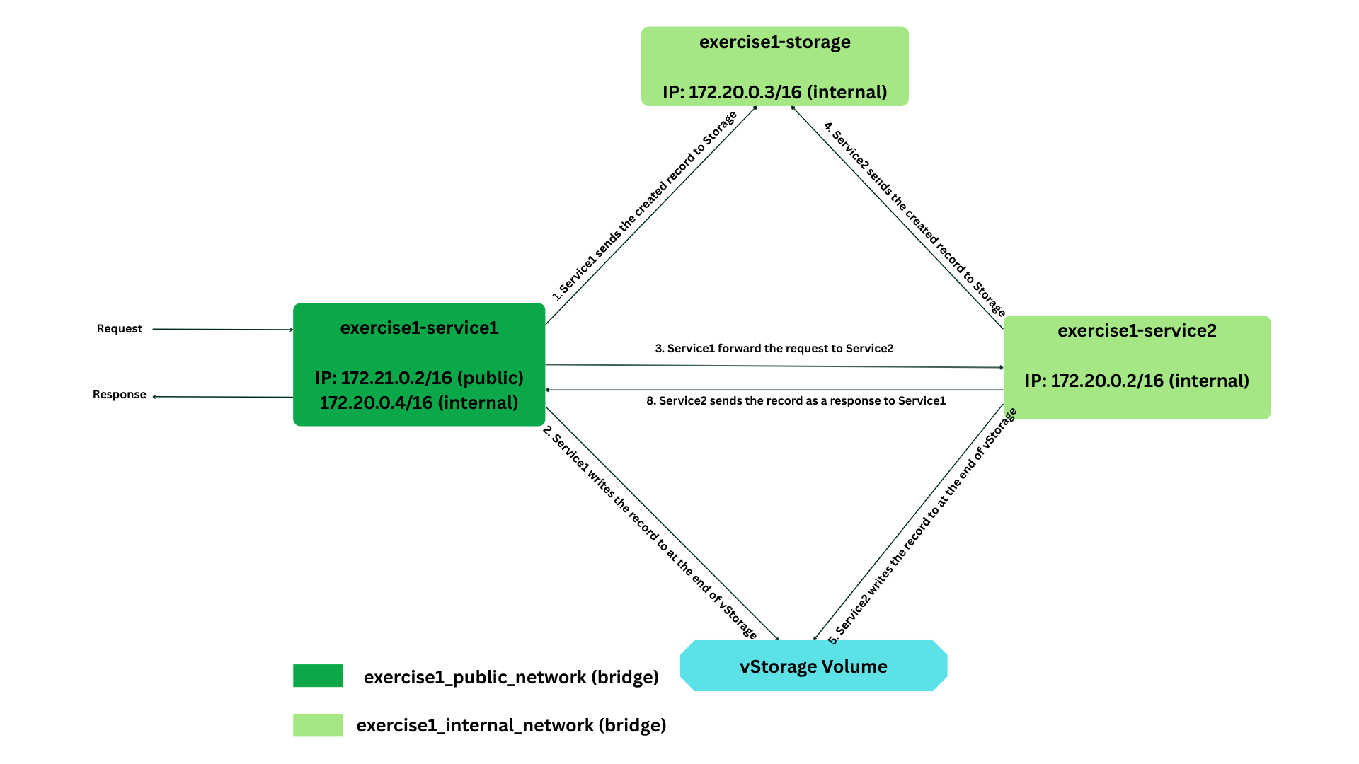

Fig: A diagram showing the services, network and storage

## Analysis status records

URL: **curl** **http://localhost:8199/log**

Response:

**Timestamp1: uptime 6.61 hours, free disk in root: 968149 Mbytes**

**Timestamp2: uptime 6.61 hours, free disk in root: 968149 Mbytes**

**Timestamp1: uptime 6.61 hours, free disk in root: 968149 Mbytes**

**Timestamp2: uptime 6.61 hours, free disk in root: 968149 Mbytes**

1. **Uptime:**

* Reads **/proc/uptime** from the container.
* Get system uptime in seconds, then converts seconds to hours.
* Correctly measuring **container uptime if D**ocker **running.** However, this uptime **does not reflect total system uptime** outside the container.

1. **Disc space:**

* Get free space **o**f the root of the container’s filesystem (/), which is usually a **virtual overlay filesystem** managed by Docker, then converts bytes to Mbytes.
* F**or better result, I could mount a host path as a volume, then check free space of the volume.**

## Analysis persistent storage

|  |  |  |
| --- | --- | --- |
| **Feature** | **Host-mounted directory (./vStorage:/app/vStorage)** | **Named Docker volume (logs:/app/Storage/logs)** |
| Ease of inspection | Yes, directly on host | No, need to use Docker commands |
| Persistence | Yes, host device | Yes, survives container removal |
| Security | Lower, file can be modified easily | Higher, isolated volume |
| Usage | Development | Production |

## Instructions for cleaning up storage

URL: **curl -X 'DELETE' 'http://localhost:8199/deleteLog'**

Response:

**true**

Hitting this endpoint **deletes both**:

**./vStorage:/app/vStorage** (host-mounted directory)

**logs:/app/Storage/logs** (named Docker volume)

## What was difficult?

* Start the Service1 API and listen for HTTP requests on **port 8199** on all available network interfaces (**0.0.0.0).**
* /proc/uptime exists only on Linux. Docker Desktop on Windows requires additional WSL ubuntu distro and could not be tested without using Docker.

## Main problems and Solution

* **No response from Service1**: solved by binding ASP.NET Kestrel to 0.0.0.0 (webBuilder.UseUrls("http://0.0.0.0:8199")) in program.cs file.
* **C# JSON handling**: dynamic vs type (bool, string) mismatch, solved by using ToObject<T>().
* **Storage volume accessibility**: chose host bind mount for inspecting vStorage file easily.

## Instructions

git clone -b exercise1 https://github.com/Samith-Pantho/DevOps-Course.git

cd DevOps-Course

cd exercise1

docker compose up -d –build

curl <http://localhost:8199/status> **(For checking Service1 and Service2 status)**

curl <http://localhost:8199/log> **(For checking Storage service data)**

curl -X 'DELETE' 'http://localhost:8199/deleteLog' **(For removing both Storage service data and vStorage data)**

docker-compose down